Task 1: Draw a simple network diagram showing two routers connected over a WAN link and label where authentication is needed to prevent unauthorized access.

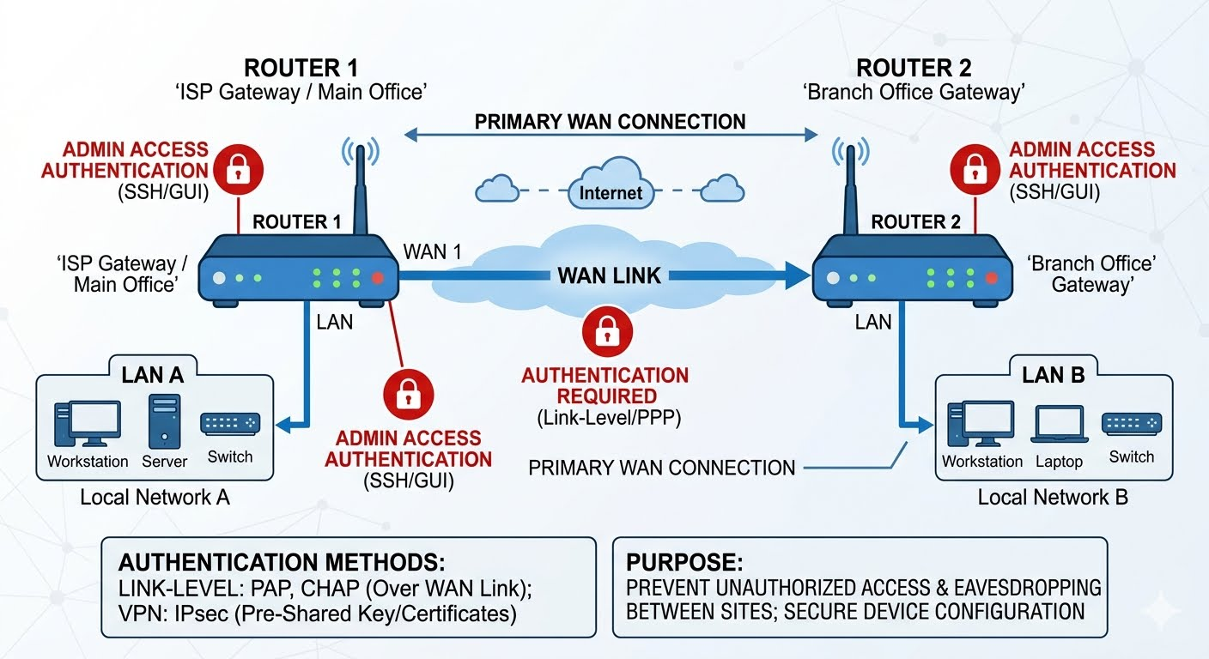

To secure a Wide Area Network (WAN) connection between two distant sites, network administrators must deploy authentication at multiple layers. Without these security checkpoints, an attacker could intercept data traveling over public infrastructure, spoof a legitimate corporate site, or gain unauthorized control over core networking hardware.
- Link-Level and Tunnel Authentication (Between Routers)This authentication takes place directly on the physical or logical WAN interface connecting Router 1 and Router It ensures that the two endpoints attempting to build a connection genuinely belong to the same enterprise network before any user data is allowed to pass between them.
The Point of Access: The serial interfaces, leased lines, or broadband connections linking the two gateway devices. The Security Risk: If an ISP line is misconfigured or tapped, a malicious router could connect to your gateway, pretend to be a trusted branch office, and siphon off sensitive corporate traffic.
Implementation Methods: PPP CHAP (Challenge Handshake Authentication Protocol): Used on point-to-point serial lines. The routers periodically verify each other's identity using a three-way handshake and an encrypted MD5 hash of a shared password. The password itself is never sent over the wire, preventing eavesdropping.
IPsec VPN Pre-Shared Keys (PSK) or Digital Certificates: When routers connect across a public WAN like the internet, they build an encrypted tunnel. During the Initial Key Exchange (IKE) phase, both routers must authenticate using a cryptographic string (PSK) or mutually verified RSA digital certificates. If the keys or certificates do not match, the tunnel fails to establish.
- Management Access Authentication (On Individual Devices)Even if the WAN link itself is heavily encrypted and authenticated, the overall infrastructure remains vulnerable if the management plane of the routers is left exposed. Management authentication controls who can log in to the operating system of the routers to view configurations, change routing tables, or shut down interfaces.
The Point of Access: Secure Shell (SSH) connections, Web GUI panels, or physical Console ports on either Router 1 or Router The Security Risk: If an attacker discovers an open management port on a router facing the internet, they can attempt brute-force login attacks. Gaining administrative access allows them to reroute your company's network traffic to an external server under their control.
Implementation Methods: Local Line Authentication: The router maintains an internal database of authorized usernames and securely hashed passwords. Anyone attempting an SSH or console session must match a local entry.
Centralized AAA (Authentication, Authorization, and Accounting): In enterprise networks, individual routers do not store user passwords. Instead, they forward all login requests to a centralized server running protocols like TACACS+ or RADIUS. This allows the company to enforce multi-factor authentication (MFA), track precisely which engineer made what configuration change, and instantly revoke access if an employee leaves the company.
- Network Admission Control / LAN Edge Authentication (Optional but Recommended) While primarily a LAN security feature, edge authentication prevents unauthorized client devices (like a rogue laptop plugged into a network switch at a remote branch) from sending data packets across the authenticated WAN tunnel back to the main headquarters. The Point of Access: The local Ethernet/LAN interfaces facing the internal switches and workstations. Implementation Method: Protocols like IEEE 802.1X force end-user devices to pass a valid corporate certificate or cryptographic credential before the local router allows their packets onto the network infrastructure.

Task 2: Configure a sample HDLC WAN connection between two routers using Packet Tracer or any network simulator, and explain why HDLC does not provide authentication. Focus on the commands used and what is missing in terms of security.
ROUTER-A CONFIGURATION (DCE Side)
Router-A# configure terminal
Router-A(config)# interface Serial0/1/0
Router-A(config-if)# ip address 10.1.1.1 255.255.255.252
Router-A(config-if)# encapsulation hdlc
Router-A(config-if)# clock rate 128000
Router-A(config-if)# no shutdown
Router-A(config-if)# exit

ROUTER-B CONFIGURATION (DTE Side)
Router-B# configure terminal
Router-B(config)# interface Serial0/1/0
Router-B(config-if)# ip address 10.1.1.2 255.255.255.252
Router-B(config-if)# encapsulation hdlc
Router-B(config-if)# no shutdown
Router-B(config-if)# exit
Key Command Verification:
- encapsulation hdlc: Explicitly sets the Layer 2 framing type to HDLC.
- clock rate 128000: Configured only on the DCE (Data Communications Equipment) side to provide physical bit timing synchronization across the WAN link.
- show interface serial 0/1/0: Running this command will show "Encapsulation HDLC" in the output, confirming the state is up.
HDLC operates strictly at Layer 2 (Data Link Layer) of the OSI model and was designed during an era when physical leased lines were considered inherently private and secure.

1. What is Missing in the Protocol Structure?
│ Flag │ Address │ Control │ Information │ FCS │ Flag │
│ (8 bits) │ (8 bits) │ (8 bits) │ (Variable Dt) │(16 bits)│ (8 bits) │
No Credentials Field: There is no field within the protocol header designed to pass a username, a hashed password, or a digital certificate.
No Security Handshake State Machine: The protocol engine lacks an internal state machine to process authentication challenges, timeouts, or retries. It only tracks states like Link Up, Link Down, or Loopback.
Implicit Trust Model: HDLC operates entirely on an implicit trust architecture. If a physical serial cable is plugged into a port and receiving a clock rate signal, the router assumes the device on the other end is trusted and immediately begins processing its network layer packets.
2. Security Vulnerabilities
Man-in-the-Middle (MitM) Interception: If a malicious actor splices into the copper or fiber physical serial line between Router-A and Router-B, they can hook up a third rogue router. The rogue router will automatically form a Layer 2 relationship without providing any proof of identity.
Spoofing: A bad actor can replace a legitimate edge router with an unauthorized machine. The upstream enterprise router will forward network routing updates and internal corporate data straight to the rogue machine without triggering any security alarms.
3. How to Secure WAN Connections (The Alternative)
Point-to-Point Protocol (PPP): PPP replaces HDLC and includes dedicated sub-protocols like PAP (Password Authentication Protocol) or CHAP (Challenge Handshake Authentication Protocol). These protocols can interface with a campus RADIUS or TACACS+ server to check passwords before bringing the interface line protocol up.\
IPsec VPNs: Encapsulating the traffic inside an IPsec tunnel at Layer 3 provides robust peer identity verification (via pre-shared keys or certificates) along with full payload encryption.

Task: 3 Set up a PPP connection between two routers in Packet Tracer and enable PAP (Password Authentication Protocol) authentication. Show the configuration commands and explain what happens if the password is incorrect.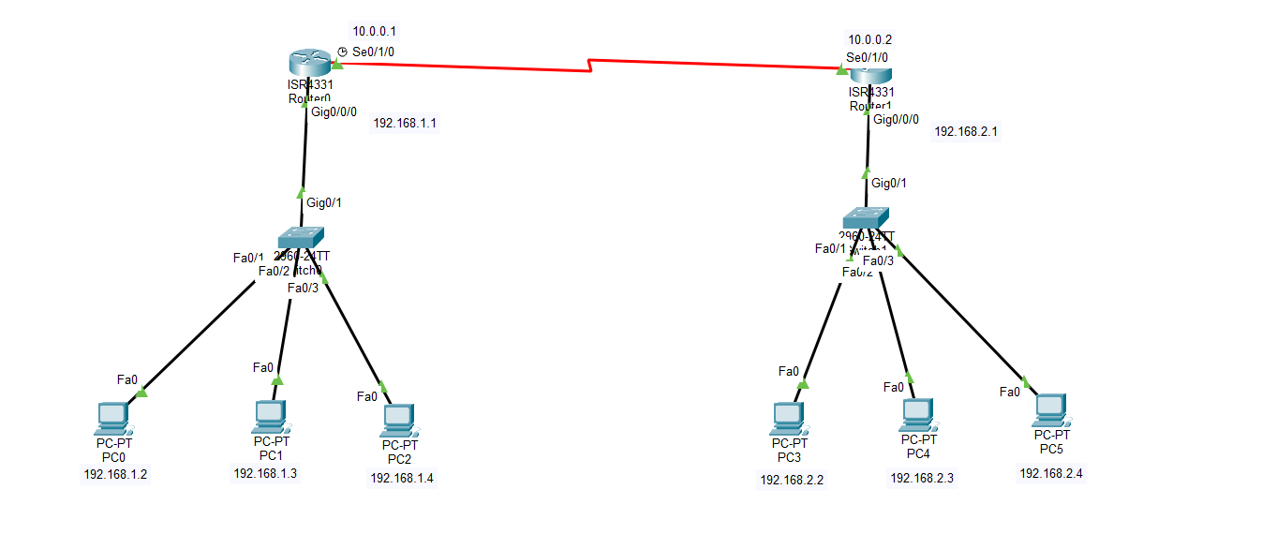
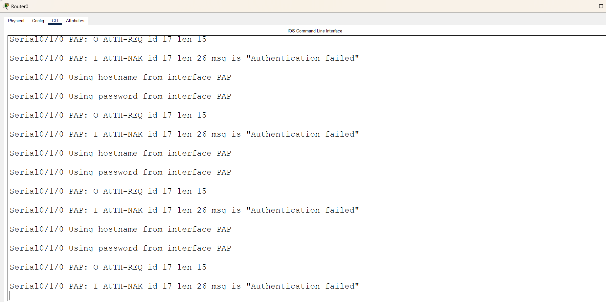
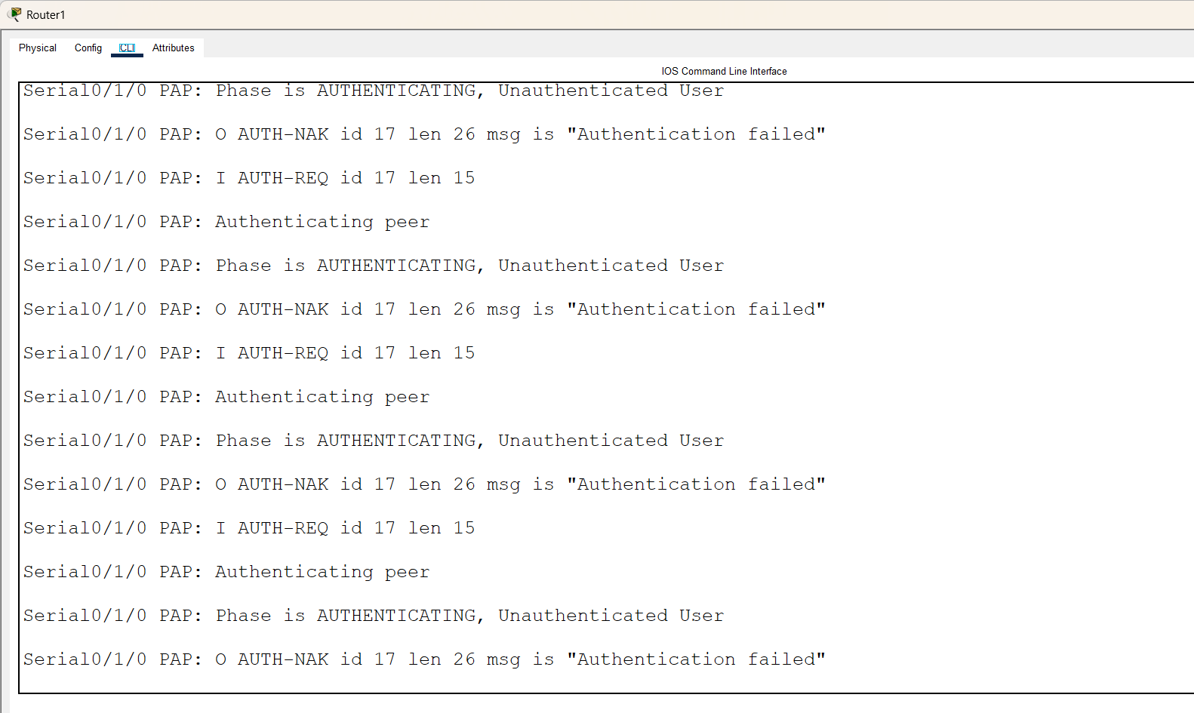

Task: 4 Modify your PPP configuration to use CHAP (Challenge Handshake Authentication Protocol) instead of PAP, and describe one key difference in how CHAP improves security over PAP.

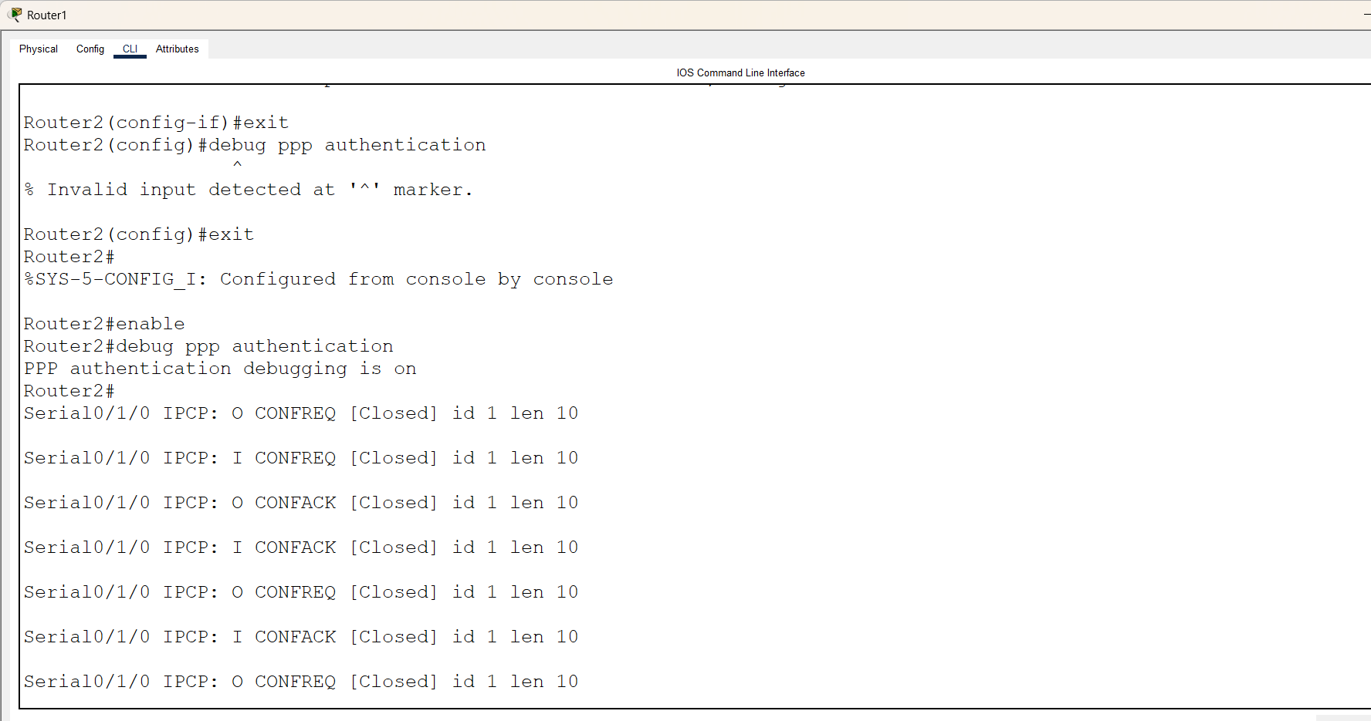

Task: 5 Research and list two real-world scenarios (such as public WiFi login or mobile data authentication) where WAN authentication protocols like PAP, CHAP, or MS-CHAP are used, and explain why authentication is critical in each case.
Scenario 1: Mobile Data Session Establishment via APN (4G/5G Cellular Networks)
When a mobile phone connects to a cellular carrier’s network (such as Airtel, Jio, or Verizon) to access mobile data, it communicates with the cell tower using cellular radio protocols. However, once the traffic reaches the carrier’s core network, a packet-data session must be established across an Access Point Name (APN) to route the user out to the open internet.
How the Protocols are Used: Carriers widely use PAP or CHAP during the packet-data network context activation phase. The smartphone's internal modem acts as the client, passing predefined carrier credentials over the air. The cellular core infrastructure extracts these credentials and uses RADIUS or Diameter to verify them against the carrier's core subscriber databases.
Why Authentication is Critical:
Billing Integrity and Plan Enforcement: The carrier must confirm that the connecting device is associated with an active, paying data subscription before allowing it to consume regional bandwidth.
Network Slice Isolation: Large enterprise organizations often lease private, secure APNs from cellular carriers for their corporate IoT fleets (e.g., shipping trackers or ATMs). PAP/CHAP verification prevents unauthorized commercial consumer phones from accidentally or maliciously routing into these private corporate backbones.
Scenario 2: WPA2/WPA3 Enterprise Login (College Campus / Corporate Wi-Fi)
When connecting to a highly secure university or corporate Wi-Fi network (such as Edu roam), users do not type in a single shared password. Instead, they are prompted for their individual corporate email and password.
How the Protocol is Used: The underlying architecture relies on IEEE 802.1X and the Extensible Authentication Protocol (EAP). Because standard MS-CHAP v2 has cryptographic vulnerabilities if exposed directly to the air, it is hidden inside a secure outer layer. Under PEAP (Protected EAP), the Wi-Fi network first creates an encrypted SSL/TLS tunnel. Once that tunnel is safe, the system safely processes the inner credentials using MS-CHAP v2.
Why Authentication is Critical:
Individual Accountability and Rogue Device Defense: On a network where everyone shares one key, rogue actions are anonymous. With enterprise authentication, if a user device is infected with malware or attempts an attack, IT administrators can pinpoint the exact user account responsible and instantly revoke their access certificates.
Dynamic Access Authorization Allocation: Verifying identity allows the network controller to apply dynamic role-based access. A professor’s authenticated session can automatically be routed into a trusted staff VLAN, while a student login is routed into a restricted student network zone.

